Accepting Submissions
Compassion and Valuing Every Person
7th Annual event in honor of Dr. Anthony Thomas, Jr
Hosted by Center for Bioethics
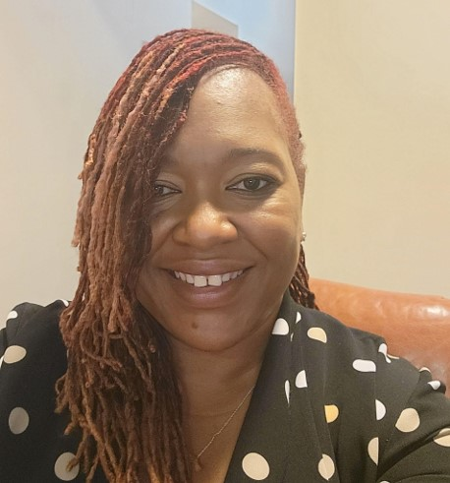
Please share your experience in healthcare regarding actions of compassion or actions that demonstrate the valuing of a person. We want to learn from you about the wisdom and power of compassionate human interactions that allow flourishing, amplify voices who have been less seen, and give rise to unexpected kindnesses. Further background about previous event information in this series can be viewed at [http://www.clevelandclinic.org/anthonythomas]

Submission Categories:

- Story, Reflection or Testimonial ($250)
- Short Poem ($100)
- Long Poem ($250)
- Visual Art Presentation ($250)

We will award up to 4 prizes and invite winners to present their submission at the annual event on September 26th at 5:00 pm. Please RSVP here. We are excited to announce that Yulanda Prude be the keynote speaker. Here is a recent article about Yulanda.
Yulanda Prude
Keynote Speaker
Associate Director, Cuyahoga County Youth Work Institute

Who is eligible: Patients, Family/Friend of Patient, Cleveland Clinic employees, others who are directly connected with Cleveland Clinic.
Award: In addition to the opportunity to present at the event, selected speakers will be awarded a monetary prize.

Submission Due Date: June 30, 2024

How to Submit: Please click the link or scan the QR Code to submit an entry.
LINK: https://forms.office.com/r/utFabAw7cZ
QR Code:

Questions: Please email Sundus Riaz at riazs2@ccf.org
Established in 2018 as, The Anthony “Tony” Thomas Jr., MD Memorial Lectures: Empathy and Valuing Every Person. Thank you to the generous donations of Colleagues, Friends, and Family of Dr. Thomas that have made this event possible (see: https://give.ccf.org/fundraiser/1863394 )

